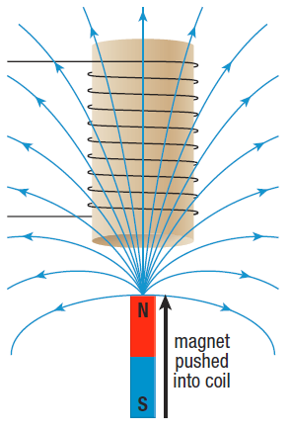**SPH3U 13.2 Lenz’s Law**

1. **Direction of induced current**

|  |  |
| --- | --- |
| Lenz’s question: |  |

|  |  |
| --- | --- |
| Newton’s 3rd law: |  |
| applied to induced currents |  |
| Lenz’s Law: |  |

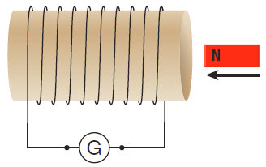 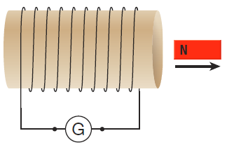

1. **Drop-tower rides**

|  |  |
| --- | --- |
| Drop-tower rides: |  |
| brakes |  |
| solution |  |

**Homework:** page 594: #1-3